Integrate AOMEI Backupper into Custom PE

Contents

Mount boot.wim 2
Load PE Registry Hive File 2
Copy Necceary Files to MountDir 4
For X86 (32 bit) PE 4
For AMD64(64 bit) PE 5
Unmount boot.wim 5

To integrate AOMEI Backupper to custom PE, you need to add registry key and other necessary files. Please follow the instruction below:

Mount boot.wim
To add registry key and files into PE, you need to know how to mount wim image file, you can find this file under the Sources folder of your ISO file.
- If you are familiar with ADK, then you can use command line to mount boot.wim file. Here is help link about how to mount wim file via DISM command https://technet.microsoft.com/en-us/library/Hh824814.aspx
- If you don’t know how to do with ADK tool, I recommend you use alternative tool like DISM++.
You can download it from this link: https://www.chuyu.me/en/index.html

Load PE Registry Hive File
In this part, you can learn how to integrate registry keys needed by AOMEI Backupper into your Custom PE Registry hive file
- Run regedit (Press Win+R, type regedit).
- Select HKEY_LOCAL_MACHINE, Click File > Load Hive
- Go to the mount folder( eg: MountDir ) created in above step, find MountDir \Windows\System32\config\SYSTEM
Note: If you use DISM++ tool, you need to close it first, or you are unable to load it.
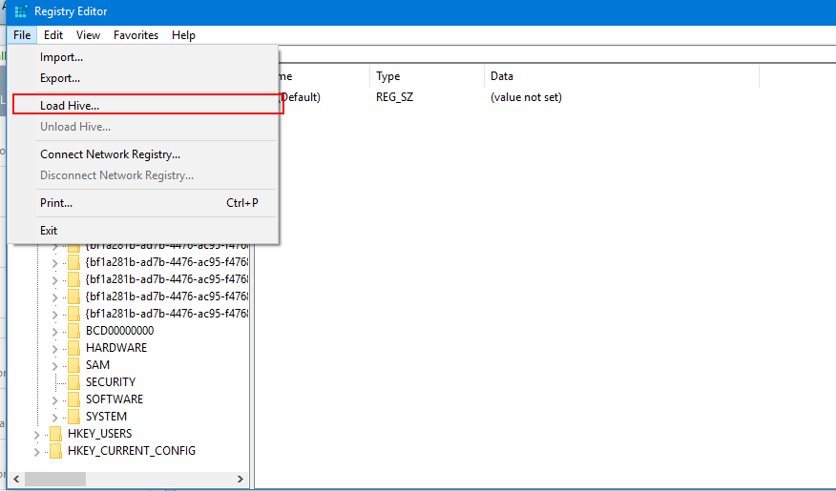

- Give a name to it , eg: PE _System 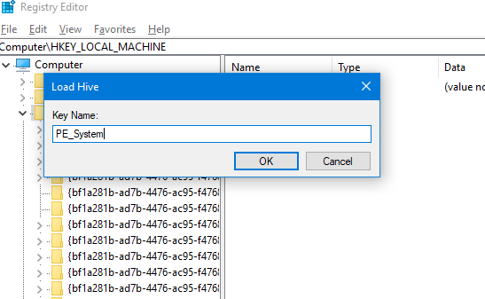
- Create a new txt document, copy and paste content below, Save it as ampe.reg

Windows Registry Editor Version 5.00

[HKEY_LOCAL_MACHINE\PE_System]

[HKEY_LOCAL_MACHINE\PE_System\ControlSet001]

[HKEY_LOCAL_MACHINE\PE_System\ControlSet001\Services]

[HKEY_LOCAL_MACHINE\PE_System\ControlSet001\Services\ammntdrv]
"DisplayName"="ammntdrv"
"ErrorControl"=dword:00000000
"ImagePath"=hex(2):53,00,79,00,73,00,74,00,65,00,6d,00,33,00,32,00,5c,00,61,00,\
6d,00,6d,00,6e,00,74,00,64,00,72,00,76,00,2e,00,73,00,79,00,73,00,00,00
"Type"=dword:00000001
"Start"=dword:00000001

[HKEY_LOCAL_MACHINE\PE_System\ControlSet001\Services\ambakdrv]
"DisplayName"="ambakdrv"
"ErrorControl"=dword:00000000
"ImagePath"=hex(2):53,00,79,00,73,00,74,00,65,00,6d,00,33,00,32,00,5c,00,61,00,\
6d,00,62,00,61,00,6b,00,64,00,72,00,76,00,2e,00,73,00,79,00,73,00,00,00
"Type"=dword:00000001
"Start"=dword:00000000

[HKEY_LOCAL_MACHINE\PE_System\ControlSet001\Services\amwrtdrv]
"DisplayName"="amwrtdrv"
"ErrorControl"=dword:00000000
"ImagePath"=hex(2):53,00,79,00,73,00,74,00,65,00,6d,00,33,00,32,00,5c,00,61,00,\
6d,00,77,00,72,00,74,00,64,00,72,00,76,00,2e,00,73,00,79,00,73,00,00,00
"Type"=dword:00000001
"Start"=dword:00000001

[HKEY_LOCAL_MACHINE\PE_System\ControlSet001\Control]
"SystemStartOptions"="winpe.wim"

[HKEY_LOCAL_MACHINE\PE_System\ControlSet001\Control\Class]

[HKEY_LOCAL_MACHINE\PE_System\ControlSet001\Control\Class\{71a27cdd-812a-11d0-bec7-08002be2092f}]
"UpperFilters"=hex(7):61,00,6d,00,62,00,61,00,6b,00,64,00,72,00,76,00,00,00,00,\
00

Note: make sure the Bold strings above are equal to the name in step 4.

- Back to regedit window, click File > Import, select new created reg file.
- When finished ,select the folder PE_System and click File > Unload Hive

Copy Necceary Files to MountDir
In this part, please refer to the corresponding system architectures:

For X86 (32 bit) PE
- Please locate the folder where AOMEI Backupper installed (you can right click Backupper desktop shortcut, click open file location ), it is in C:\Program Files\AOMEI Backupper by default.
- Copy files below to MountDir/Windows/system32/
"C:\Program Files\AOMEI Backupper\driver\i386\ambakdrv.sys"
"C:\Program Files\AOMEI Backupper\driver\i386\ammntdrv.sys"
"C:\Program Files\AOMEI Backupper\driver\i386\amwrtdrv.sys"
- Create a new folder named AomeiBackupper in MountDir/Program Files then copy all files and folders excluding those shown in picture below from C:\Program Files\AOMEI Backupper

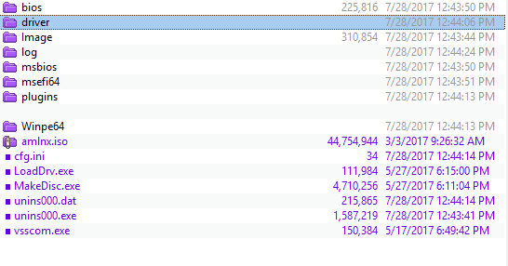

For AMD64(64 bit) PE
- Locate the folder where AOMEI Backupper installed (you can right click Backupper desktop shortcut, click open file location), it is in C:\Program Files(x86)\AOMEI Backupper by default.
- Copy files below to MountDir/Windows/system32/
"C:\Program Files (x86)\AOMEI Backupper\driver\amd64\ambakdrv.sys"
"C:\Program Files (x86)\AOMEI Backupper\driver\amd64\ammntdrv.sys"
"C:\Program Files (x86)\AOMEI Backupper\driver\amd64\amwrtdrv.sys"
- Create a new Folder in MountDir/Program Files, give it a name as you want, then copy all files from C:\Program Files(x86)\AOMEI Backupper\Winpe64 to the new folder created. Besides, please also copy below items to the new folder created.
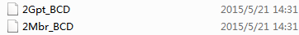

Unmount boot.wim
Now, you can save the boot.wim image, replace the old one then unmount it.
If you are using DISM++, Click File > Save Image.
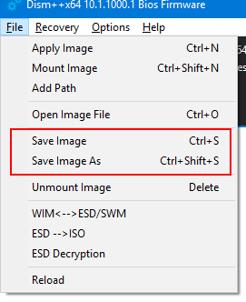
Summary:
In order to run AOMEI Backupper in Custom PE, you need to:
- Add registry key to PE
- Copy necessary files/drivers to PE

